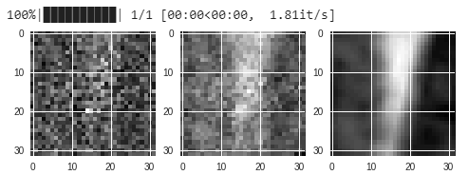

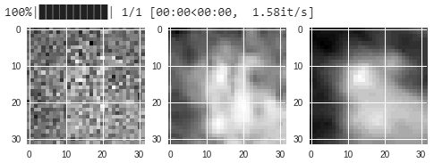

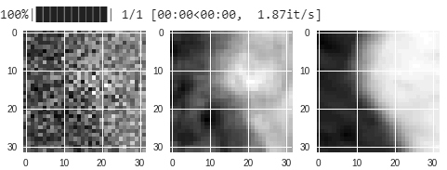

Valid loss

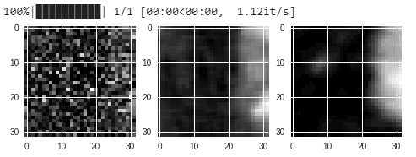

Loss: 4.50:

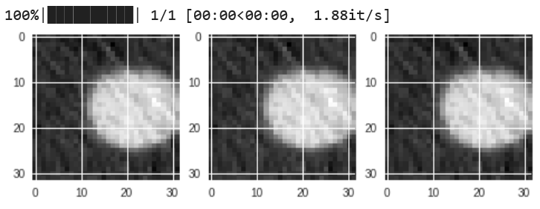

Verification task results:

CUSTOM - Balanced variant (auc)

Noise Inter Intra

------- -------- --------

Easy 0.952802 0.927342

Hard 0.935712 0.90286

Tough 0.907797 0.866072

CUSTOM - Imbalanced variant (ap)

Noise Inter Intra

------- -------- --------

Easy 0.884978 0.826117

Hard 0.83224 0.748747

Tough 0.752166 0.650537

CUSTOM - mAP

Easy Hard Tough mean

-------- -------- --------- --------

0.329607 0.150999 0.0608267 0.180477

CUSTOM - mAP 10K queries

Noise 100 500 1000 5000 10000 15000 20000

------- -------- -------- -------- -------- -------- -------- --------

Easy 0.832393 0.718672 0.671093 0.560876 0.515329 0.489569 0.473572

Hard 0.785755 0.620193 0.549975 0.392863 0.332639 0.300922 0.282002

Tough 0.702068 0.484685 0.400712 0.239026 0.187053 0.161916 0.148025

mean 0.773405 0.60785 0.540593 0.397589 0.345007 0.317469 0.3012

**SHALLOW** SGD lr 0.00001 momentum 0.9 epoch 1 2T1V **(0)**

7.6059 8.7115

**SHALLOW** SGD lr 0.00001 momentum 0.9 epoch **5** 2T1V

7.0250 8.3562

**SHALLOW** SGD lr 0.00001 momentum 0.9 epoch 1 **F**T5V

6.7243 6.6818

**SHALLOW** SGD lr 0.00001 momentum 0.9 epoch 10 **10**T10V

|  |  |  |  |  |  |  |  |
| --- | --- | --- | --- | --- | --- | --- | --- |
| Train**(1)** | Val | Train (lr 0.0001) **(2)** | Val (lr 0.0001) | Train (lr 0.0005) **(3)** | Val (lr 0.001) | Train (lr 0.000001)**(4)** | Val (lr 0.000001) |
| 7.6532 | 7.3347 | 11.2018 | 7.0370 | 56.2081 | 29.3687 | 10.6744 | 8.5866 |
| 6.5375 | 6.4792 | 8.5998 | 9.0203 | 27.1035 | 26.7144 | 7.7241 | 7.8490 |
| 6.3346 | 6.2736 | 8.0255 | 7.5798 | 26.0139 | 27.6923 | 7.2686 | 7.5788 |
| 6.2137 | 6.1965 | 7.7461 | 8.6457 | 25.4466 | 28.9308 | 7.0539 | 7.4152 |
| 6.1158 | 6.2234 | 7.5360 | 8.2453 | 25.1160 | 30.0401 | 6.9206 | 7.3305 |
| 6.0474 | 6.0609 | 7.3579 | 8.9664 | 24.8562 | 23.0613 | 6.8274 | 7.2363 |
| 5.9865 | 5.9866 | 7.2523 | 9.1478 | 24.5531 | 25.5651 | 6.7617 | 7.1727 |
| 5.9402 | 6.0853 | 7.1494 | 6.8719 | 24.1860 | 22.8943 | 6.7073 | 7.1800 |
| 5.9116 | 5.9195 | 7.0575 | 6.9279 | 24.0421 | 24.4961 | 6.6660 | 7.1892 |
| 5.8664 | 5.9927 | 6.9835 | 6.2668 | 23.6946 | 27.0683 | 6.6321 | 7.1572 |
|  |  |  |  |  |  |  |  |
|  |  |  |  |  |  |  |  |
|  |  |  |  |  |  |  |  |
|  |  |  |  |  |  |  |  |
|  |  |  |  |  |  |  |  |
|  |  |  |  |  |  |  |  |
|  |  |  |  |  |  |  |  |

**SHALLOW** Adam lr 0.00001 beta1 0.9 beta2 0.999 eps 1e-8 epoch 1 FTFV

7.7265

**SHALLOW** Adam lr 0.0001 beta1 0.9 beta2 0.999 eps 1e-8 epoch 1 FTFV

6.1390 5.5198

**SHALLOW** Adam lr **0.001** beta1 0.9 beta2 0.999 eps 1e-8 epoch 1 FTFV

5.5326 5.2156

**SHALLOW** Adam lr 0.01 beta1 0.9 beta2 0.999 eps 1e-8 epoch 1 FTFV

5.8621 5.7855

**SHALLOW** Adam lr 0.001 beta1 0.9 beta2 0.999 eps 1e-8 epoch 1 **10T10V**

**SHALLOW** Adam lr 0.001 beta1 0.9 beta2 0.999 eps 1e-8 epoch 10 10T10V

|  |  |  |  |  |  |  |  |
| --- | --- | --- | --- | --- | --- | --- | --- |
| Train **(5)** | Valid | Train (red lr)(lr0=0.01) | Valid (red lr) | Train (BN)(lr0=0.001) | Valid(BN)(lr0=0.001) | Train(BN)(lr=**0.01**) | Valid(BN)(lr=**0.01**) |
| 6.1457 | 5.7968 | 6.1732 | 5.6765 | 11.2482 | 6.7315 | 6.9604 | 5.8717 |
| 5.2349 | 5.4667 | 5.5164 | 5.5601 | 6.9254 | 6.1580 | 5.9276 | 6.3148 |
| 5.0911 | 5.3463 | 5.4317 | 5.5917 | 6.4245 | 6.3346 | 5.6207 | 6.5460 |
| 5.0179 | 5.2905 | 5.0474 | 5.3445 | 6.1184 | 5.9012 | 5.5064 | 5.9321 |
| 4.9722 | 5.2823 | 5.0096 | 5.2959 | … | … | 5.4104 | 6.0603 |
| 4.9426 | 5.3365 | 4.9870 | 5.2780 | … | … | 5.3633 | 5.6049 |
| 4.9210 | 5.2135 | 4.9724 | 5.2940 | … | … |  |  |
| 4.9067 | 5.2922 | 4.9158 | 5.2451 | … | … |  |  |
| 4.8929 | 5.2177 | 4.9124 | 5.2364 | … | … |  |  |
| 4.8781 | 5.1901 | 4.9091 | 5.2352 | … | … |  |  |
|  |  |  |  |  |  |  |  |

|  |  |  |  |  |
| --- | --- | --- | --- | --- |
| Train (red lr)(lr0=0.01**)(6)** | valid(red lr)(lr0=0.01)(patience=1) | Train | valid |  |
| 7.0100 | 5.2693 |  |  |  |
| 5.8439 | 5.1296 |  |  |  |
| 5.7450 | 5.8613 |  |  |  |
| 5.3861 | **4.7909** |  |  |  |
| 5.3326 | **4.7668** |  |  |  |
| 5.2926 | **4.7911** |  |  |  |
| 5.2154 | **4.7287** |  |  |  |
| 5.2076 | **4.7551 (STOP)** |  |  |  |
|  |  |  |  |  |

|  |  |  |  |
| --- | --- | --- | --- |
| Train | Valid | Train (eps=0.1) | Test (eps=0.1) |
| 6.1457 | 5.7968 |  |  |
| 5.2349 | 5.4667 |  |  |
| 5.0911 | 5.3463 |  |  |
| 5.0179 | 5.2905 |  |  |
| 4.9722 | 5.2823 |  |  |
| 4.9426 | 5.3365 |  |  |
| 4.9210 | 5.2135 |  |  |
| 4.9067 | 5.2922 |  |  |
| 4.8929 | 5.2177 |  |  |
| 4.8781 | 5.1901 |  |  |

**SHALLOW** various optimizer epoch 10 10T10V

|  |  |  |  |  |  |
| --- | --- | --- | --- | --- | --- |
| Train (RMSProp) | Valid | Train (Adadelta) | Valid | Train (Adagrad) | Valid |
|  |  |  |  |  |  |
|  |  |  |  |  |  |
|  |  |  |  |  |  |
|  |  |  |  |  |  |
|  |  |  |  |  |  |
|  |  |  |  |  |  |
|  |  |  |  |  |  |

**UNET** Adam lr 0.001 beta1 0.9 beta2 0.999 eps 1e-8 epoch 1 FTFV

5.7961 5.5733

**UNET** Adam lr 0.001 beta1 0.9 beta2 0.999 eps 1e-8 epoch 10 10T10V

|  |  |  |  |
| --- | --- | --- | --- |
| Train (w/o BN) | Test (w/o BN) | Train (w 1/2BN wo dropout)(red lr 0.0001)(batch50) | Test (w 1/2BN wo dropout)(red lr 0.0001) (batch50) |
| 5.9478 | 5.0300 | 9.8660 | 5.5193 |
| 5.0639 | 4.8610 | 6.5741 | 5.5097 |
| 4.9192 | 5.0139 | 5.8010 | 5.6784 |
| **4.8420** | **4.8620** | 5.4749 | 5.6262 |
| **4.7914** | **4.6773** | 5.1966 | 5.6806 |
| **4.7542** | **4.6534** | 4.7014 | 4.9972 |
| **4.7310** | **4.7132** | 4.6518 | 4.8089 |
| **4.7085** | **4.7094** | 4.6217 | 4.6914 |
| **4.6944** | **4.7032** | **4.6024** | 4.7561 |
| **4.6922** | **4.6984** | **4.5746** | 4.7707 |
|  |  | **4.5636** | 4.7478 |
|  |  | **4.5078** | 4.7176 |
|  |  | **4.5041** | 4.7677 |
| Train (w 1/2BN wo dropout)(red lr 0.0001)(batch50)(bn momentum0.6) | Test (w 1/2BN wo dropout)(red lr 0.0001)(batch50)(bn momentum0.6) | Train (w 1/2BN wo dropout)(red lr 0.001)(batch50) | Test (w 1/2BN wo dropout)(red lr 0.001) (batch50) |
| 8.7950 | 6.0991 |  |  |
| 6.1921 | 5.6476 |  |  |
| 5.8095 | 8.3089 |  |  |
| 5.5668 | 5.3720 |  |  |
| 5.3848 |  |  |  |
| 5.2505 |  |  |  |
| 5.1658 |  |  |  |
| 5.0743 |  |  |  |
|  |  |  |  |
|  |  |  |  |
|  |  |  |  |

<https://machinelearningmastery.com/adam-optimization-algorithm-for-deep-learning/>

<https://medium.com/octavian-ai/which-optimizer-and-learning-rate-should-i-use-for-deep-learning-5acb418f9b2>

<https://towardsdatascience.com/fingerprint-denoising-and-inpainting-using-fully-convolutional-networks-e24714c3233>

display curve:

<https://machinelearningmastery.com/display-deep-learning-model-training-history-in-keras/>

HardNet

SGD lr 0.1 momentum 0.0 epoch 1 100kT10kV **(0)**